Space.com (http://www.space.com/20330-cosmic-microwave-background-explained-infographic.html)

**Cosmic Microwave Background: Big Bang Relic Explained (Infographic)**

By Karl Tate, SPACE.com Infographics Artist | April 3, 2013 07:33am ET

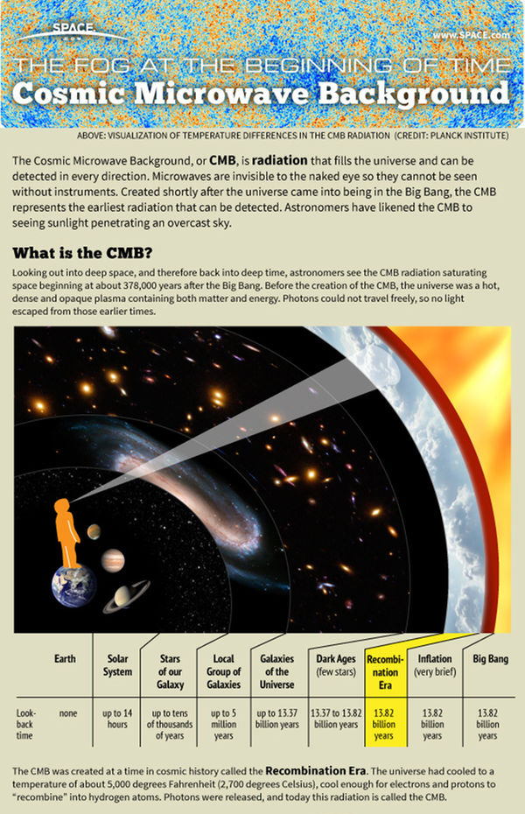

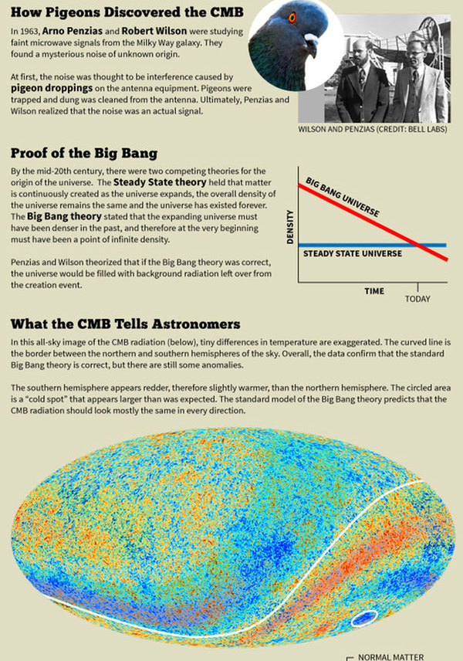

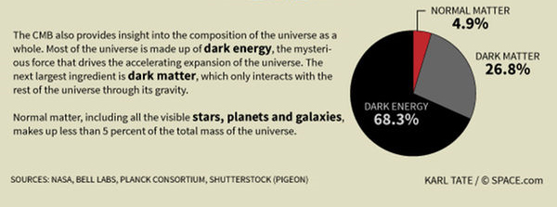

The CMB radiation tells us the age and composition of the universe and raises new questions that must be answered.

*Credit: Karl Tate, SPACE.com Infographics Artist*

The Cosmic Microwave Background, or CMB, is radiation that fills the universe and can be detected in every direction. Microwaves are invisible to the naked eye so they cannot be seen without instruments. Created shortly after the universe came into being in the Big Bang, the CMB represents the earliest radiation that can be detected. Astronomers have likened the CMB to seeing sunlight penetrating an overcast sky.

Looking out into deep space, and therefore back into deep time, astronomers see the CMB radiation saturating space beginning at about 378,000 years after the Big Bang. Before the creation of the CMB, the universe was a hot, dense and opaque plasma containing both matter and energy. Photons could not travel freely, so no light escaped from those earlier times.

The CMB was created at a time in cosmic history called the Recombination Era. The universe had cooled to a temperature of about 5,000 degrees Fahrenheit (2,700 degrees Celsius), cool enough for electrons and protons to “recombine” into hydrogen atoms. Photons were released, and today this radiation is called the CMB.

In 1963, Arno Penzias and Robert Wilson were studying faint microwave signals from the Milky Way galaxy. They found a mysterious noise of unknown origin.

At first the noise was thought to be interference caused by pigeon droppings on the antenna equipment. Pigeons were trapped and dung was cleaned from the antenna. Ultimately Penzias and Wilson realized that the noise was an actual signal.

By the mid-20th century, there were two competing theories for the origin of the universe.  The Steady State theory held that matter is continuously created as the universe expands, the overall density of the universe remains the same, and the universe has existed forever. The Big Bang theory stated that the expanding universe must have been denser in the past, and therefore at the very beginning must have been a point of infinite density.

Penzias and Wilson theorized that if the Big Bang theory was correct, the universe would be filled with background radiation left over from the creation event.

In an all-sky image of the CMB radiation, the southern hemisphere appears redder, therefore slightly warmer, than the northern hemisphere A "cold spot" in the southern hemisphere appears larger than was expected. The standard model of the Big Bang theory predicts that the CMB radiation should look mostly the same in every direction.

The CMB also provides insight into the composition of the universe as a whole. Most of the universe is made up of dark energy, the mysterious force that drives the accelerating expansion of the universe. The next largest ingredient is dark matter, which only interacts with the rest of the universe through its gravity.

Normal matter, including all the visible stars, planets and galaxies, makes up less than 5 percent of the total mass of the universe.